RV Parking Guidelines
Southern Mesa RV Park is laid out with concrete pad at each Site.
- Back in and leave space in front of the electric pedestal. Please be aware of the water spigot as well. There is plenty of parking on right side of the concrete pad for the RV rig.
- The left side of the pad is for your car or truck vehicle. Please do not park on the concrete pad. Please do not park into the street.
Concrete Pad in Center of Site
Park your vehicle to the Left of the pad | The pad is now your patio. | Back your RV rig to the Right of the pad.

- When hooking up your sewer hose, please use a lift to keep it off the ground. See illustration.
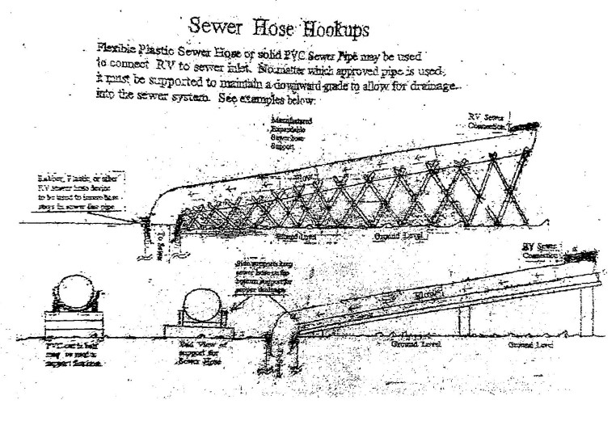
Will you be staying with us for an extended length of time?
Do you want to receive mail?
Ask office staff how you can get a mailbox key.

